*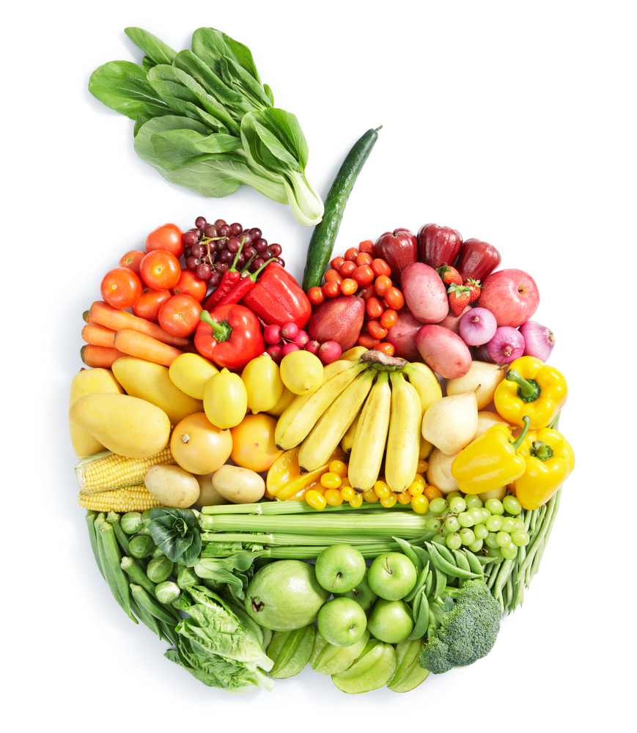Get the Lead Out*

*Southern United Neighborhoods*

Vitamin C Helps Iron Absorb

* Peppers
* Brussels Sprouts
* Citrus Fruits
* Kale
* Radishes
* Kiwi
* Strawberries
* Broccoli
* Potatoes
* Tomatoes

More Effective when

Combined with Vitamin C

*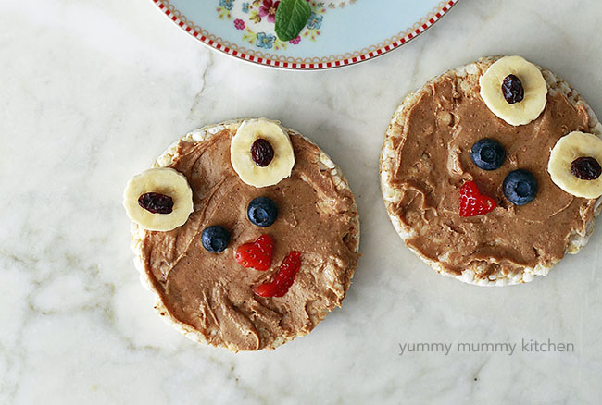*

A Community Voice

2221 St. Claude Avenue

504-941-2852

[info@acommunityvoice.org](mailto:info@acommunityvoice.org)

acommunityvoice.org

Healthy Kids’ Snacks & Meals (for adults too!)

* Grilled Cheese with Tomatoes
* Whole Grain Crackers & Cheese
* Baked Fish
* Cereal with added Iron & Raisins
* Apples & Peanut Butter
* Beans & Rice
* Trail Mix with, Nuts, Raisins, Sunflower Seeds
* Sweet Potato
* Yogurt & Raisins
* Kebabs with lean meats, peppers
* Pear Halves with Shredded Cheese
* Baked Apples
* Bean Dip
* Chili with Beans

Iron Blocks Lead from Being Absorbed

* Spinach & other dark leafy greens
* Lean Beef
* Chicken Liver
* Clams
* Mollusks
* Mussels
* Oysters
* Sardines
* Beans
* Lentils
* Brown Rice
* Raisins, dates, prunes
* Skinless Poultry
* Nuts

Calcium for Bone Health

& Lead Detox

* Milk
* Cheese
* Fennel
* Salmon
* Tofu
* Yogurt
* Greens

Removing Toxins

* Cherries & Berries
* Rosemary
* Apples
* Green Tea
* Plums
* Apples
* Turmeric

Cooking Corn Bread, Rice, Pasta and more in an Iron Pot gives an added Iron Boost